**CSE 551 - Robot Alexa Final Project**

WHAT WORKS

I opted to do the ‘A’ level of the assignment. That being said, I cannot find any errors or bugs in my setup or implementation of the alexa assignment. As an additional note, I made my grid 200 x 200, as instructed, but my counts start at 0 and end at 199. The bottom left corner represents

(0, 0) and the top right corner is (199, 199)

Alexa User Guide

Alexa Skill Name: **RobotSkill**

Invocation: **noah robot**

Intents:

1. **Location Request:** 
   1. **Invoke:**  {name} what is its position ({name} is either alice or bob  
      **Full call:** alexa ask noahs robot alice what is its position  
      **Response:** alice is currently at position 146 by 64 facing North, they can move 135 units forward
2. **Turn Request:**
   1. **Invoke**: {name} turn {turndirection} **or** {name} to turn {turndirection}

({name} is either alice or bob, {turndirection} is either left or right)

* 1. **Full call:** alexa ask noahs robot bob to turn left
  2. **Response:** bob turned left

1. **Move Request:**
   1. **Invoke:** {name} to move {forb} **or**

{name} to move {forb} by {steps} **or**

{name} to move {forb} {steps} **or**

{name} to move {forb} by {steps} steps **or**

{name} to move {forb} {steps} steps

* 1. **Full call:** alexa ask noahs robot alice to move forward fifty steps
  2. **Response:** Okay!

URL TO S3

<http://dunnnm2-451-alexabucket-robots.s3-website-us-east-1.amazonaws.com/>

URL TO API Gateway API

<https://kowy99xtbe.execute-api.us-east-1.amazonaws.com/default>

GET AND PUT CURL Calls

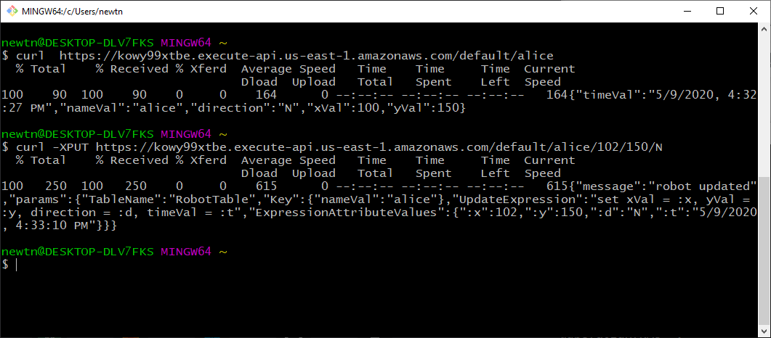

Gitlab Code

<https://gitlab.csi.miamioh.edu/dunnnm2/cse451-dunnnm2-web/tree/master/FinalProject>

Lambda Skill Names

API Gateway Lambda Function: robotAPI

Alexa Skill Lambda Function: RobotSkill

API Gateway Name

API Gateway Name: movie-list

Alexa Working Calls

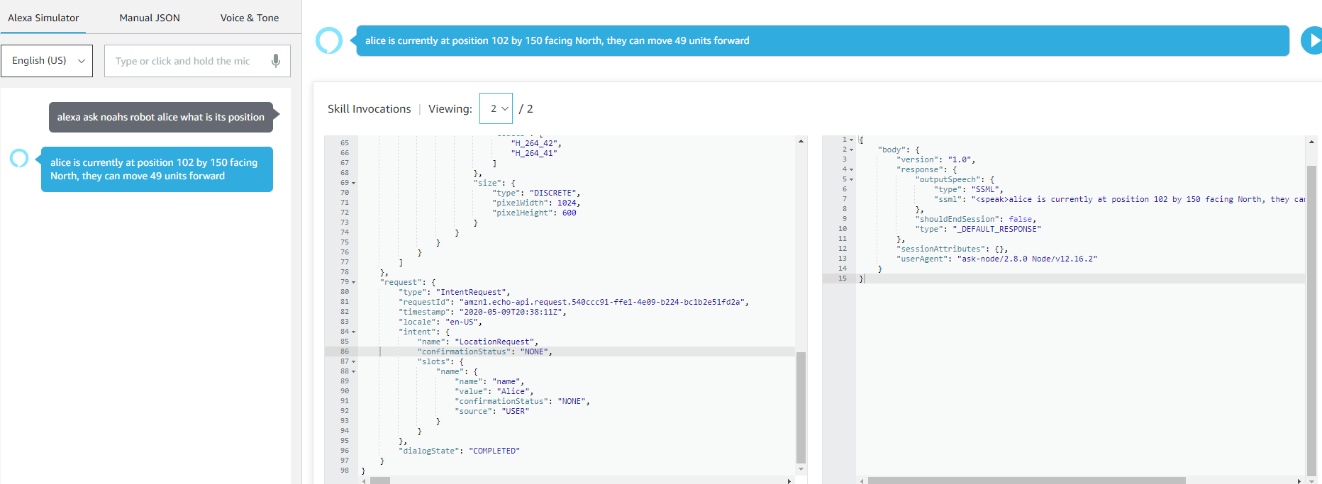

=====================================================================

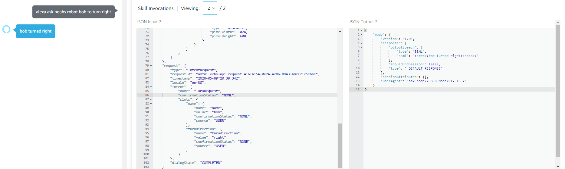

=====================================================================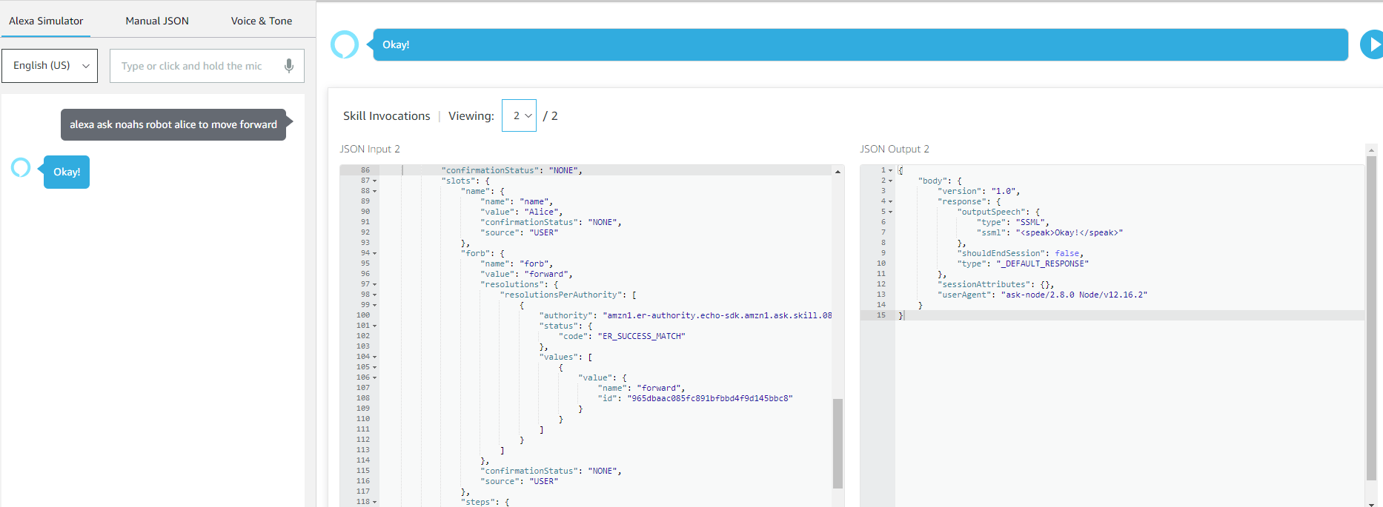

=====================================================================

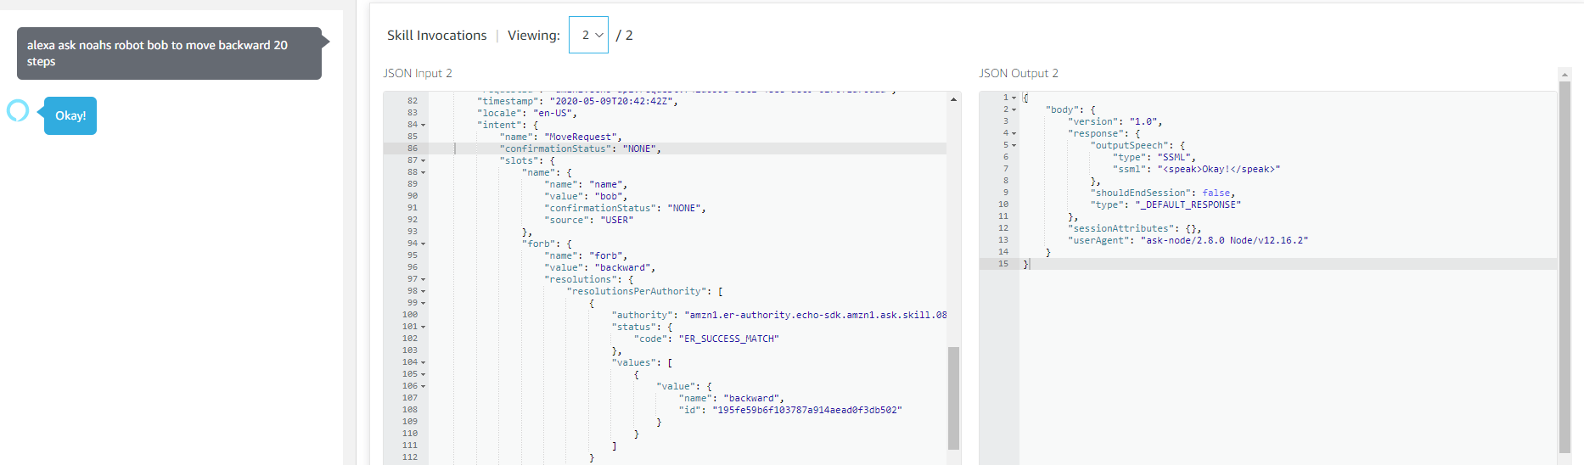

=====================================================================

Alexa Error Handle Calls

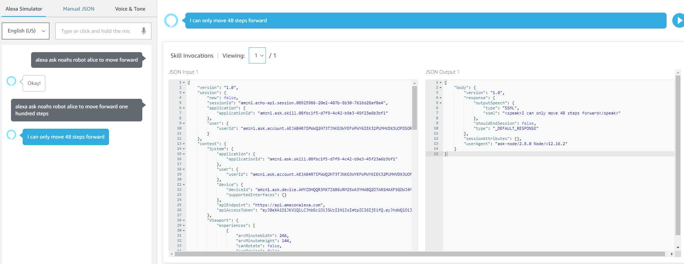

=====================================================================

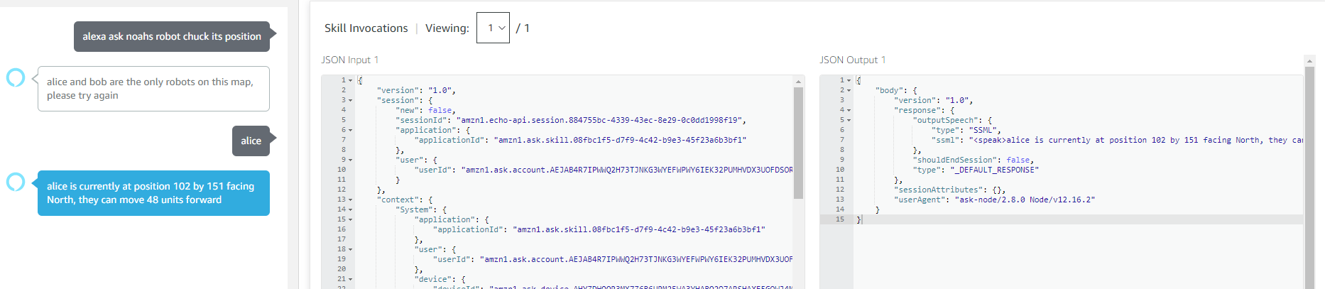

=====================================================================

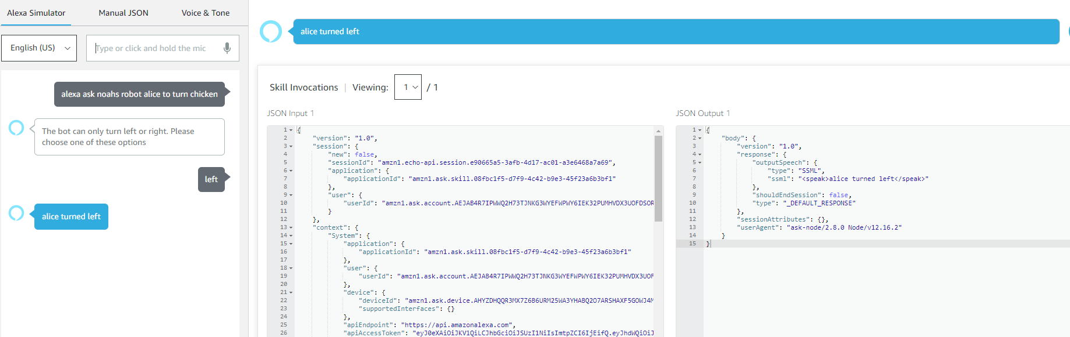

W3C Validation Checker

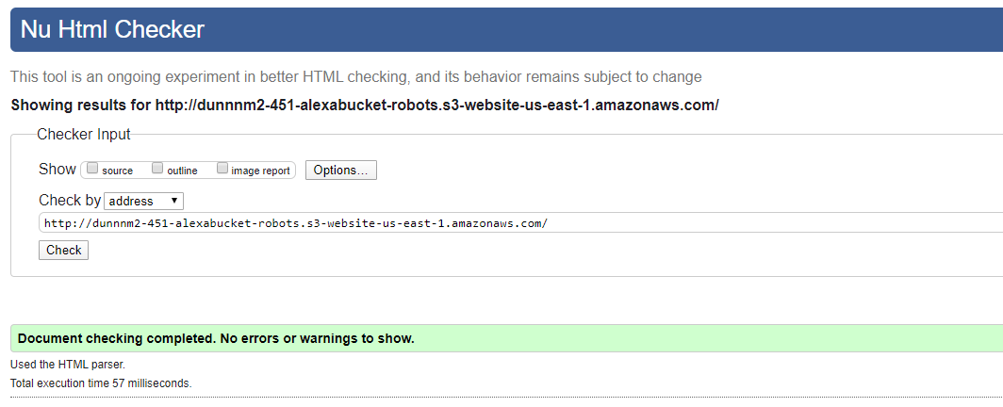

Youtube Solution

<https://www.youtube.com/watch?v=ffjjpVG3Nno>